**Understanding Ohm's Law and Simple Circuit Design:**

## **Ohm's Law definition**

**Ohm's Law** states that the current flowing in a circuit is directly proportional to the applied potential difference and inversely proportional to the resistance in the circuit.

In other words by doubling the voltage across a circuit the current will also double. However if the resistance is doubled the current will fall by half.

In this mathematical relationship the unit of resistance is measured in Ohms.

## **Ohm's Law formula**

The Ohm's Law formula or equation is very straightforward.

Ohm's law can be expressed in a mathematical form:

V=IR

**Where:**

V = voltage expressed in Volts

I = current expressed in Amps

R = resistance expressed in Ohms

The formula can be manipulated so that if any two quantities are known the third can be calculated.

I=V/R

**AND**

R=V/I

## **Ohm's law triangle**

To help remember the formula it is possible to use a triangle with one side horizontal and the peak at the top like a pyramid. This is sometimes known as the Ohm's law triangle.

In the top corner of the Ohms law triangle is the letter V, in the left hand corner, the letter I, and in the right hand bottom corner, R.

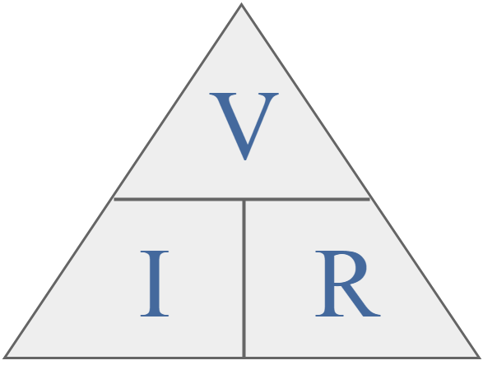

To use the triangle cover up the unknown quantity and then and then calculate it from the other two. If they are in line they are multiplied, but if one is on top of the other then they should be divided. In other words if current has to be calculated the voltage is divided by the resistance i.e. V/R and so forth.

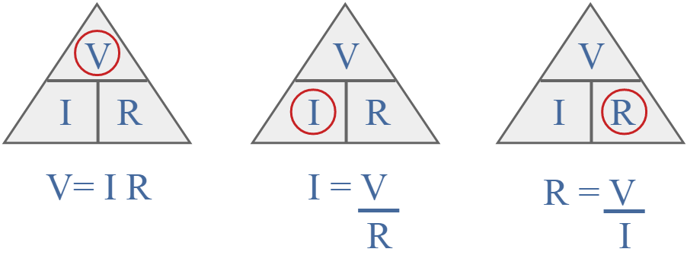

If the voltage has to be calculated then it is found by multiplying the current by the resistance i.e. I x R.

## **Ohms Law calculation example**

If a voltage of 10 volts is placed across a 500 ohm resistor determine the amount of current that will flow.

If the voltage has to be calculated then it is found by multiplying the current by the resistance i.e. I x R.

## **Ohms Law calculation example**

If a voltage of 10 volts is placed across a 500 ohm resistor determine the amount of current that will flow.

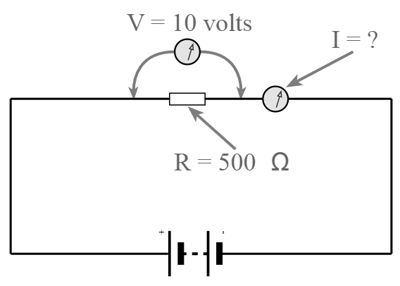

Looking at the Ohms Law triangle the current is the unknown leaving the voltage and resistance as the known values

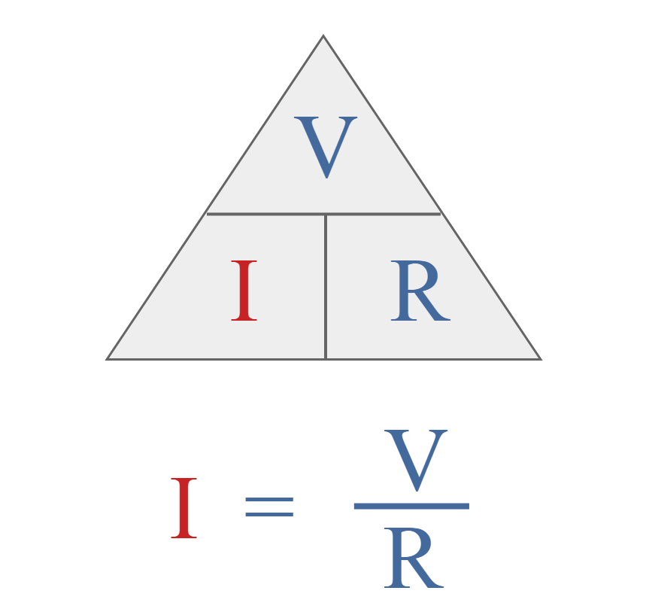

In this way the current is found by dividing the voltage by the resistance.

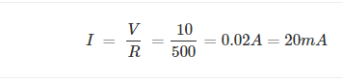

**Example 2**

In a similar way it is possible to use Ohm's Law to find the resistance if the current and voltage are known. Take, for example, a voltage of 10 volts, and a current 0.1A. Using the Ohm's Law triangle, it can be seen that:

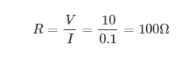

**Example 3**

Finally, the other combination is that is the resistance and current are known, then it is possible to calculate the voltage expected across the resistance. Take the example of a distance of 250 Ω which has a current of 0.1 A flowing through it, then the voltage can be calculated as below:

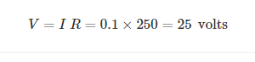

# **Simple Circuits using OHMs law:**

